User Manual Specification
Release Version -1.1
For
Meghna Solar Ltd.
Concern Topic: Leasing Management

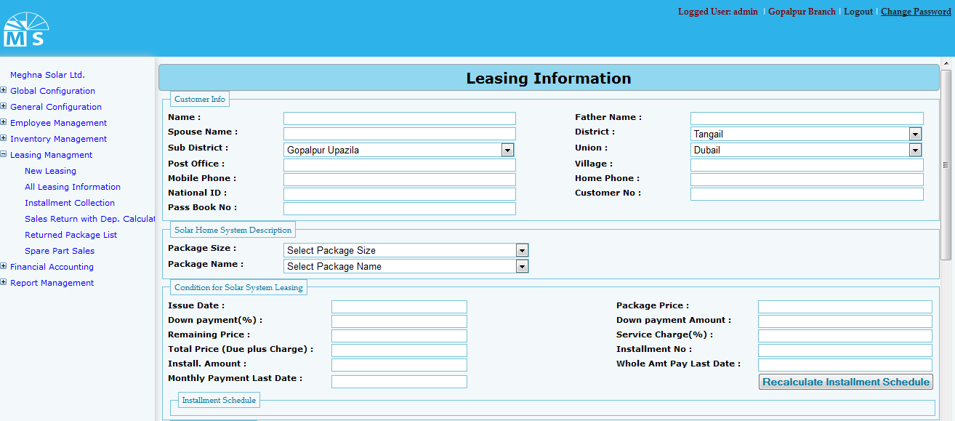

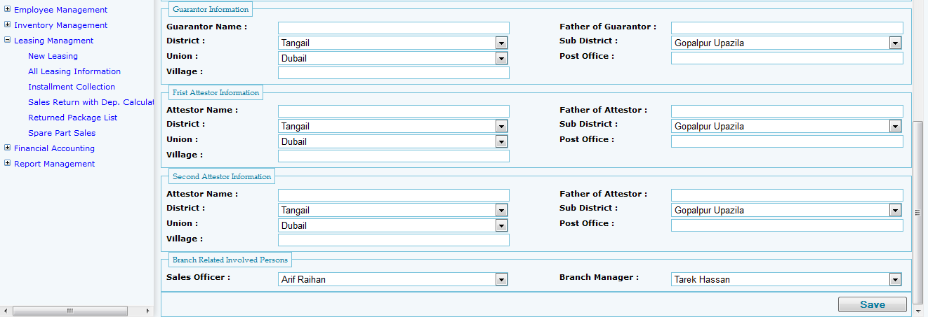

New Leasing Information entry page

Here in Leasing Information user needs to enter information related to leasing. They are Customer Info, Solar home system information, Condition of solar system leasing, installment info, guarantor info, first attester and second attester information. After providing all required information stated above user need to press save button to save all the information in the entry form. After saving the information user will get success message for successfully completion of task and error message for any error or blank field in the form.

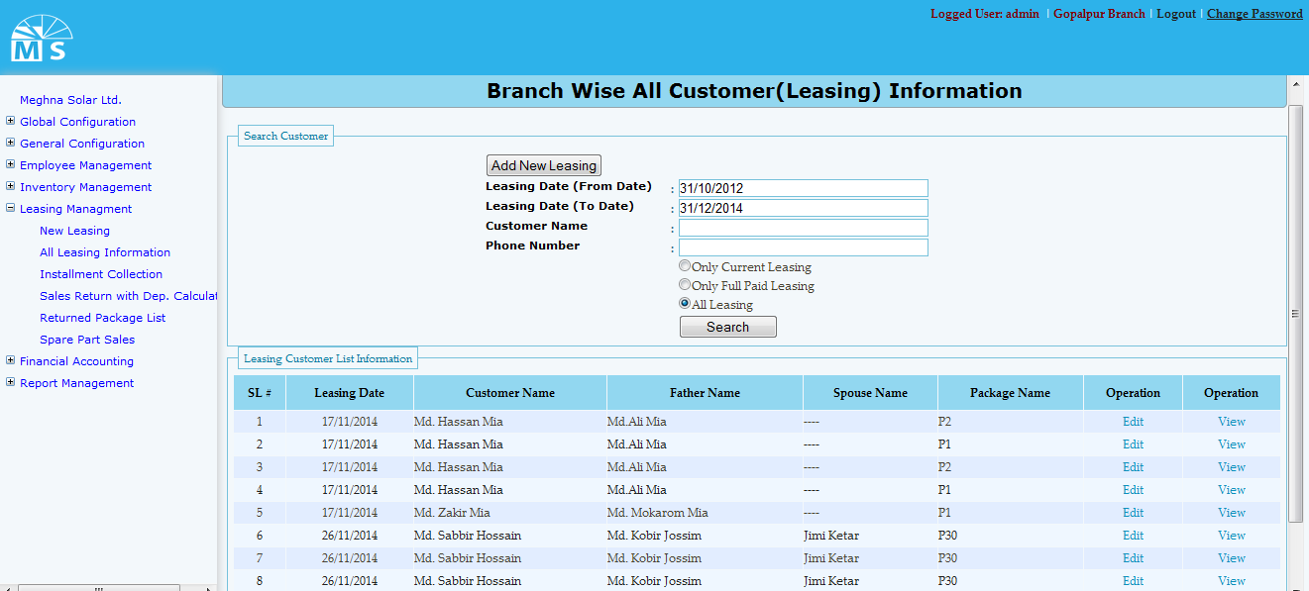

All Leasing Information

Here in All Leasing information user can search leasing information by providing leasing date range. like the upper picture user can search only providing date range. But for specific person user need to provide customer name and his phone no. There are three category for search. They are: only current leasing, only full paid leasing and last one is all leasing. After the search button clicked if data exist among the date range that will be shown in the grid view below. User can View and edit info from the grid view.
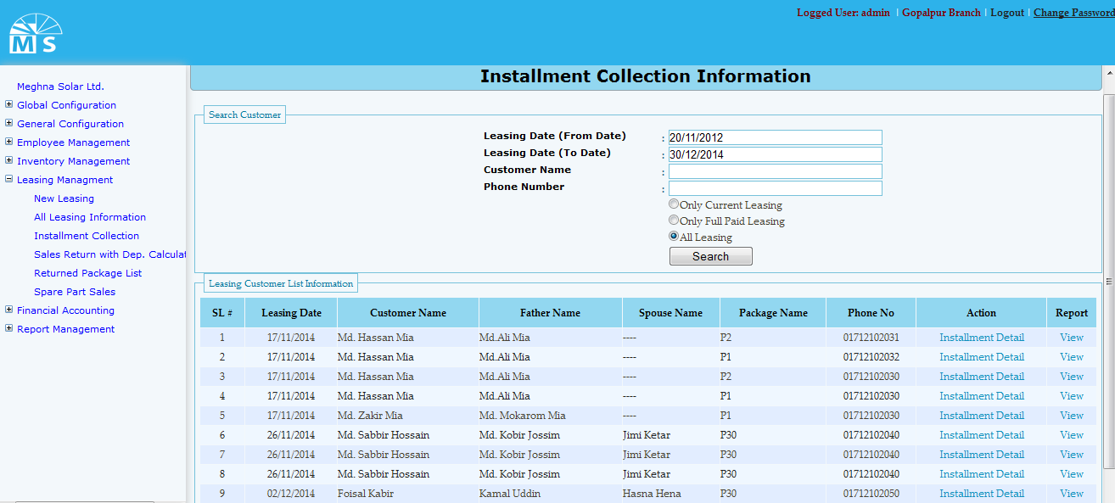

Factory Info Setup

In Factory info setup user needs to entry leasing date range (from date and to date) for searching installment collection information. User can search in three category. They are Only current, full paid and All leasing. For specific Custermer report user need to give input of customer name and Phone no of the customer before clicking search button.User can view install ment detail from the information in Gridview.

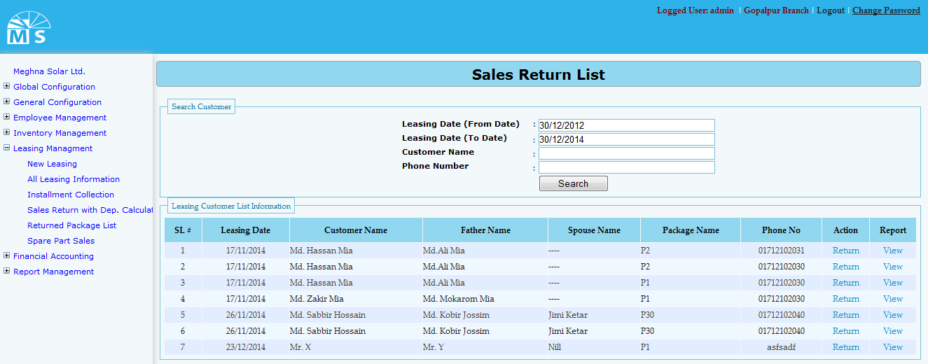

Sales Return List

In Sales Return List user needs to provide date range and customer name or phone number for specific sales return information. Search information will be visible in the grid view below from where user can return sales and view report of that Sales event.

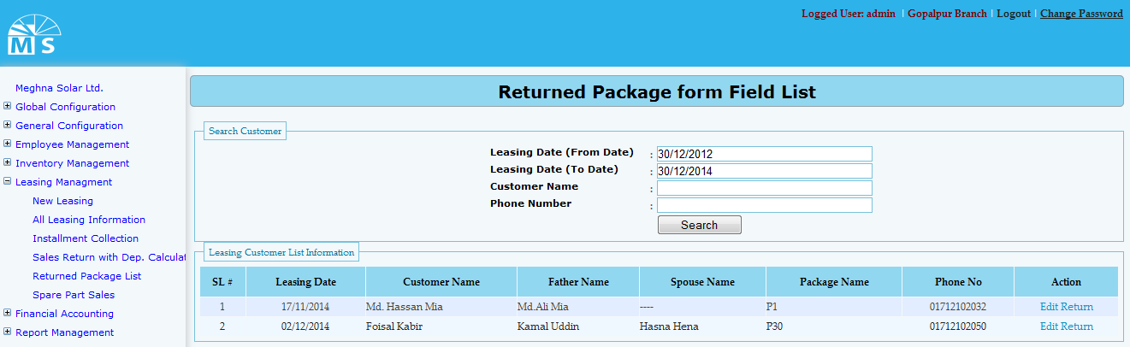

Returned Package from field List

Here user needs to enter Leasing date range like before and for specific customer report need to provide Customer name and phone number. Searched information will be shown in the grid view below from which user can edit the sales return information if needed.

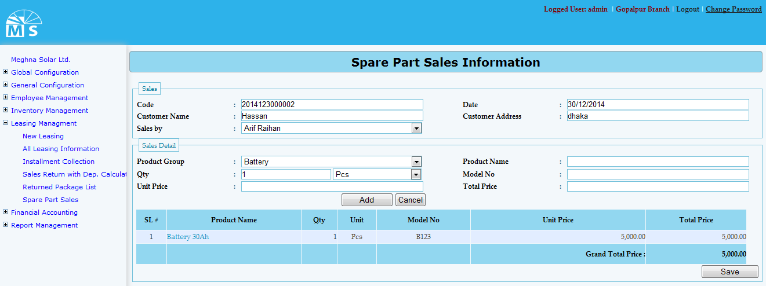

Spare Parts Sales Information

Here in Spare Parts Sales form there are two sections. They are - Sales and Sales details. In Sales part user need to enter Code,Customer details and Sales by Information. Then in Sales detail part user needs to select Product group and Measurement unit from drop down list. User also need to provide Unit price, Model No and Total price to add sales details information. At last user need to click Save button for saving all the information provided above.

